**Object-Oriented Programming**

**Lab Session #3**

You are required to implement the following design as well as a main() method in a another class to test your implementation:

1. Shapes (25 points)

Implement the hierarchy below where

* + MyShape is an abstract class with an abstract Draw method,
  + MyBoundedShape is an abstract class with an abstract GetArea method,
  + MyLine, MyOval, MyRectangle are concrete classes

In the main() method,

* + Ask user to select 5 shapes and input their dimension
  + Draw selected shapes
  + Compute and show area of selected shapes if they are a bounded shape

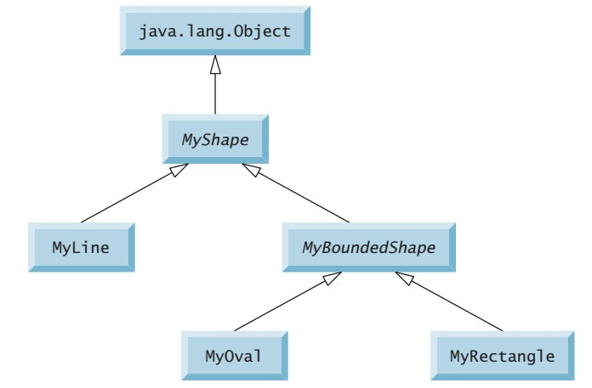

public abstract class MyShape {

public abstract void Draw();

}

public abstract class MyShapeEx extends MyShape {

public abstract double GetArea();

}

import java.awt.Graphics;

import java.util.Scanner;

import javax.swing.JComponent;

import javax.swing.JFrame;

class Testline extends JComponent {

private int x, y;

public Testline() {

Scanner scanner = new Scanner(System.in);

System.out.println("Drawing Line");

System.out.print("x: ");

x = scanner.nextInt();

System.out.print("y: ");

y = scanner.nextInt();

scanner.close();

}

public void paint(Graphics g) {

g.drawLine(20, 20, x, y);

}

}

public class MyLine {

public void drawline() {

JFrame window = new JFrame();

window.setBounds(40, 40, 300, 300);

window.getContentPane().add(new Testline());

window.setVisible(true);

}

}

public abstract class MyBoundedShape {

private double area;

public abstract void GetArea();

public double getArea() {

return area;

}

public void setArea(double area) {

this.area = area;

}

}

public class MyLine {

public void drawline() {

JFrame window = new JFrame();

window.setBounds(40, 40, 300, 300);

window.getContentPane().add(new Testline());

window.setVisible(true);

}

}

import java.awt.Color;

import java.awt.Graphics;

import java.util.Scanner;

import javax.swing.JComponent;

import javax.swing.JFrame;

class Testrect extends JComponent {

private int width, length;

public Testrect() {

Scanner scanner = new Scanner(System.in);

System.out.println("Drawing Rectangle");

System.out.print("Width: ");

width = scanner.nextInt();

System.out.print("Length: ");

length = scanner.nextInt();

GetArea();

scanner.close();

}

public void paint(Graphics g) {

g.drawRect (20, 20, width, length);

}

public int Calarea() {

System.out.println("Area = " +width*length);

return width*length;

}

public double GetArea() {

return Calarea();

}

}

public class MyRectangle {

public void drawRec() {

JFrame window = new JFrame();

window.setDefaultCloseOperation(JFrame.EXIT_ON_CLOSE);

window.setBounds(40, 40, 400, 400);

window.getContentPane().add(new Testrect());

window.setVisible(true);

}

}

import java.awt.Graphics;

import javax.swing.JComponent;

import javax.swing.JFrame;

import java.util.Scanner;

class Testoval extends JComponent {

private int width, length;

public Testoval() {

Scanner scanner = new Scanner(System.in);

System.out.println("Drawing Oval ");

System.out.print("Width: ");

width = scanner.nextInt();

System.out.print("Length: ");

length = scanner.nextInt();

GetArea();

scanner.close();

}

public void paint(Graphics g) {

g.drawOval (20, 20, width, length);

}

public int Calarea() {

System.out.printf("Area = " +3,14*width*length);

return width*length;

}

public double GetArea() {

return Calarea();

}

}

public class MyOval {

public void drawOval() {

JFrame window = new JFrame();

window.setBounds(30, 30, 300, 300);

window.getContentPane().add(new Testoval());

window.setVisible(true);

}

}

import java.util.Scanner;

public **class Main** {

public static void main(String[] args) {

Scanner scanner = new Scanner(System.in);

String chooseShape;

System.out.println("Choose the Shape that you want to draw \n (Line-Oval-Rectangle)");

chooseShape = scanner.nextLine();

if(chooseShape.equals("Line")) {

MyLine l = new MyLine();

l.drawline();

}

if(chooseShape.equals("Oval")) {

MyOval o = new MyOval();

o.drawOval();

}

if(chooseShape.equals("Rectangle")) {

MyRectangle rec = new MyRectangle();

rec.drawRec();

}

}

}

1. 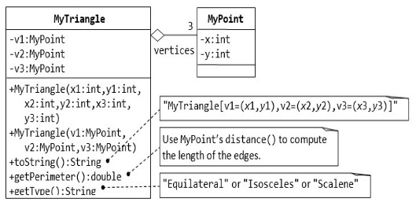Triangle and Point (25 points)

public class MyTriangle {

private MyPoint a;

private MyPoint b;

private MyPoint c;

private double d1;

private double d2;

private double d3;

public MyTriangle(int x1, int y1, int x2, int y2, int x3, int y3) {

a = new MyPoint(x1, y1);

b = new MyPoint(x2, y2);

c = new MyPoint(x3, y3);

d1 = a.getDistance(b);

d2 = b.getDistance(c);

d3 = c.getDistance(c);

}

public MyTriangle(MyPoint v1, MyPoint v2, MyPoint v3) {

this.a = v1;

this.b = v2;

this.c = v3;

d1 = v1.getDistance(v2);

d2 = v1.getDistance(v3);

d3 = v2.getDistance(v3);

}

public String toString() {

return String.format("MyTriangle A(%d, %d), B(%d, %d), C(%d, %d)]", a.getX(), a.getY(), b.getX(), b.getY(), c.getX(), c.getY());

}

public double getPeri() {

return d1 + d2 + d3;

}

public String getTypeTri() {

if (d1 == d2 && d2 == d3)

return "Your Triangle is Equilateral";

else if (d1 == d2 || d1 == d3 || d2 == d3)

return "Your Triangle is Isosceles";

else

return "Your Triangle is Scalene";

}

}

public class MyPoint {

private int x;

private int y;

public MyPoint(int x, int y) {

this.x = x;

this.y = y;

}

public int getX() {

return x;

}

public int getY() {

return y;

}

public double getDistance(MyPoint p) {

return Math.sqrt(Math.pow((x - p.x), 2) + (Math.pow((y - p.y), 2)));

}

}

import java.util.Scanner;

public class **Mainex2** {

public static void main(String[] args) {

Scanner scanner = new Scanner(System.in);

System.out.println("Enter the dimension of the 1st point");

System.out.print("x = ");

int x1 = scanner.nextInt();

System.out.print("y = ");

int y1 = scanner.nextInt();

System.out.println("Enter the dimension of the 2nd point");

System.out.print("x = ");

int x2 = scanner.nextInt();

System.out.print("y = ");

int y2 = scanner.nextInt();

System.out.println("Enter the dimension of the 3rd point");

System.out.print("x = ");

int x3 = scanner.nextInt();

System.out.print("y = ");

int y3 = scanner.nextInt();

scanner.close();

MyPoint p1 = new MyPoint(x1, y1);

MyPoint p2 = new MyPoint(x2, y2);

MyPoint p3 = new MyPoint(x3, y3);

MyTriangle tri = new MyTriangle(p1, p2, p3);

System.out.println(tri.toString());

System.out.println(tri.getTypeTri());

System.out.print("Perimeter = ");

System.out.println(tri.getPeri());

}

}

1. Person, Student & Staff (25 points)

import java.util.Scanner;

class Person {

private String name, address;

public Person(String name, String address) {

this.name = name;

this.address = address;

}

public String getName(){

return name;

}

public String getAddress() {

return address;

}

public void setAddress(String address) {

this.address = address;

}

@Override

public String toString() {

return "Person[" +

"Name: '" + name + '\'' +

", Address: '" + address + '\'' +']';

}

}

class Student extends Person {

private String program;`

private int year;

private double fee;

public Student(String name, String address, String program, int year, double fee) {

super(name, address);

this.program = program;

this.fee = fee;

this.year = year;

}

public String getProgram() {

return program;

}

public void setProgram(String program) {

this.program = program;

}

public double getFee() {

return fee;

}

public void setFee(double fee) {

this.fee = fee;

}

public int getYear() {

return year;

}

@Override

public String toString() {

return "=> Student{" +

super.toString()+

" Program: '" + program + '\'' +

", year=" + year +

", fee=" + fee +

'}';

}

}

class Staff extends Person {

private String school;

private double pay;

public Staff(String name, String address, String school, double pay) {

super(name, address);

this.pay = pay;

this.school = school;

}

public String getSchool() {

return school;

}

public void setSchool(String school) {

this.school = school;

}

public double getPay() {

return pay;

}

public void setPay(double pay) {

this.pay = pay;

}

@Override

public String toString() {

return "=> Staff{"+

super.toString()+

"school: '" + school + '\'' +

", pay: " + pay +

'}';

}

}

public class Excercise3 {

public static void main(String[] args) {

String stsname;

String stsadd;

String program;

int year;

double fee;

Scanner scanner = new Scanner(System.in);

System.out.println("Student info");

System.out.print("Name: ");

stsname = scanner.nextLine();

System.out.print("Address: ");

stsadd = scanner.nextLine();

System.out.print("Program: ");

program = scanner.nextLine();

System.out.print("School Year: ");

year = scanner.nextInt();

System.out.print("Fee: ");

fee = scanner.nextInt();

Student st = new Student(stsname,stsadd, program, year, fee);

System.out.println(st.toString());

System.out.println("Staff info");

System.out.print("Name: ");

String stfname = scanner.nextLine();

System.out.print("Address: ");

String stfadd = scanner.nextLine();

System.out.print("School: ");

String school = scanner.nextLine();

System.out.print("Pay: ");

double pay = scanner.nextInt();

Staff staff = new Staff(stfname,stfadd, school, pay);

System.out.println(staff.toString());

}

}

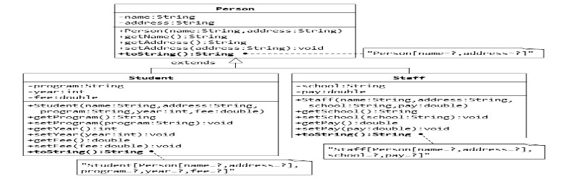

1. Point2D and Point3D (25 points)

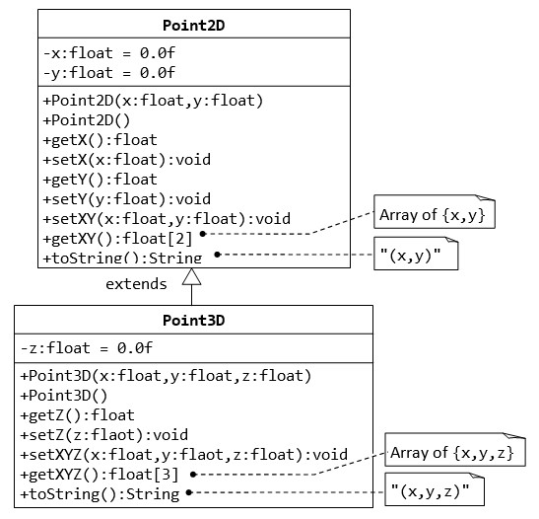

import java.util.ArrayList;

import java.util.Scanner;

class Point2D {

private float x = 0.0f;

private float y = 0.0f;

public Point2D(float x, float y) {

this.setX(x);

this.setY(y);

}

public Point2D() {

x = 0;

y = 0;

}

public float getX() {

return x;

}

public void setX(float x) {

this.x = x;

}

public float getY() {

return y;

}

public void setY(float y) {

this.y = y;

}

public void setXY(float x, float y) {

setX(x);

setY(y);

}

public ArrayList<Float> getXY() {

ArrayList<Float> lo = new ArrayList<Float>();

lo.add(x); lo.add(y);

return lo;

}

public String toString() {

return "Point2D: A(" +x+","+y+")";

}

}

class Point3D extends Point2D{

private float z = 0.0f;

public float getZ() {

return z;

}

public void setZ(float z) {

this.z = z;

}

public Point3D(float x, float y, float z) {

super.setXY(x, y); // qua class khac nen phai dung setter de gan gia tri x va y

this.setZ(z);

}

public Point3D() {

z = 0;

}

public void setXYZ(float x, float y, float z) {

super.setXY(x, y);

setZ(z);

}

public ArrayList<Float> getXYZ() {

ArrayList<Float> lo = new ArrayList<Float>();

lo.add(getX()); lo.add(getY()); lo.add(z); // qua class khac nen phai dung getter de gan gia tri x va y

return lo;

}

@Override

public String toString() {

return "Point3D: B("+getX()+","+getY()+"," + z + ")";

}

}

public class Excercise4{

public static void main(String[] args) {

Scanner scanner = new Scanner(System.in);

float x2, y2, x3, y3, z;

System.out.println("Input Point 2D");

System.out.print("X = ");

x2 = scanner.nextFloat();

System.out.print("Y = ");

y2 = scanner.nextFloat();

System.out.println("Input Point 3D");

System.out.print("X = ");

x3 = scanner.nextFloat();

System.out.print("Y = ");

y3 = scanner.nextFloat();

System.out.print("Z = ");

z = scanner.nextFloat();

scanner.close();

Point2D p2d = new Point2D(x2 , y2);

Point3D p3d = new Point3D(x3 , y3, z);

System.out.println(p2d.toString());

System.out.println(p3d.toString());

}

}